ABSTRACT
This project article presents an Automatic Temperature-Controlled Brooder House, which was built to maintain optimal temperature conditions for the early growth stages of poultry. In the common and traditional poultry brooding systems, temperature is often manually controlled, which leads to low productivity, higher losses of poultry, and sometimes mismanagement of resources.
In this project, the system uses a microcontroller integrated with a DS18B20 and a temperature sensor to monitor the atmospheric temperature outside and within the brooder house. The system operate based on the temperature readings of the sensor and automatically activate and deactivate heating element and the fan to maintain the desired temperature range. The temperature values that the temperature sensors detect will be displayed on an LCD unit.
The method used to develop this system will include circuit design and simulation, programming of the microcontroller using Arduino IDE, and practical construction of the control system. The project was tested to ensure it can successfully maintain the brooder temperature within the optimal range of 28°C to 38°C, showing a high level of performance.
I concluded that this project showed that automation in poultry brooding can improve productivity and ensure the chicks are safe. The system in this project can be used as a model for small and medium-scale dairy farmers looking to upgrade their operations for better results.

TABLE OF CONTENTS
ABSTRACT i
TABLE OF CONTENTS ii
TABLE OF FIGURES v
CHAPTER ONE 1
INTRODUCTION 1
1.1 Background of the study 1
1.2 Problem statement 2
1.3 Research objectives 3
1.3.1 Broad Objective: 3
1.4 Scope of the study 4
CHAPTER TWO 5
LITERATURE REVIEW 5
2.0 Introduction 5
2.1 Conceptual review 5
2.3 Theoretical Framework 7
2.4 Thermodynamic principles 8
2.5 Embedded systems theory 9
2.6 Review of empirical literature 10
CHAPTER THREE 13
METHODOLOGY 13
3.0 Introduction 13
3.1 Research design 13
3.1.2 System Design and Description 14
3.2 Circuit diagram 14
3.3 Flow chart diagram 15
3.4 Block diagram 15
3.5 Images of the Prototype 16
3.2 Materials and Components 17
3.3 Method of Data Collection and System Testing 18
3.4 Instrumentation (Construction, Validity, and Reliability) 18
3.5 Instrument Construction 19
3.6 System requirement analysis 19
3.7 Design and Construction of Circuits 20
3.8 Configuring the ATMEGA 328-P Control System Code Development 20
3.9 System Testing 21
3.10 Evaluation and Calibration 21
3.11 Documentation and Reporting 22
3.12 Data Collection 22
3.13 Conclusion 23
CHAPTER FOUR 25
4.0 Introduction 25
4.1 Selecting Components 25
4.2 System Implementation 26
4.2.1 Wiring 26
4.3 Results and Testing 27
4.4 Comparing two heating elements (incandescent bulb and heater) 28
4.5 Cost Estimation 29
4.6 Challenges Encountered 30
4.6.1 Sensor Calibration 30
4.6.2 LCD Flicker 30
4.6.3 Relay Switching Noise 30
4.6.4 Code Debugging 30
CHAPTER 5 31
CONCLUSION AND RECOMMENDATIONS 31
5.0 Introduction 31
5.1 Recommendations 32
5.1.1 Safety Enhancements 32
5.1.2 AI-Based Control Algorithms 32
5.1.3 Summary 32
APPENDIX 34
Cost Estimated 34
Programming Code 34
REFERRENCES 44

TABLE OF FIGURES
Figure 3.1: Circuit Diagram of the System 14
Figure 3.2: Flow Chart Diagram of how the Command Flows in the System 15
Figure 3.3: System Block Diagram 15
Figure 3.4: Connections of the Prototype 16
Figure 3.5: Close-up of the connection in a plastic container 16
Figure 4.1:.…………………………………………………….……………………..35

CHAPTER ONE

INTRODUCTION

1.1 Background of the study
Poultry farming is a very big part of agricultural production, which contributes to food consumption, economic growth, and jobs all over the globe. Brooding is the part of raising chickens that takes the most time and effort, form requirement analysis 27 weeks of their lives. Chicks are really vulnerable right now, and they require a stable environment and temperature to grow, develop, and stay alive. The traditional way to brood is with manual or heating methods like charcoal stoves and kerosene lamps. This can be hard because they don't let you control the temperature very well, cost a lot of energy, pose a fire risk, and require more work.
Also, history shows that chicken farming has moved from small-scale activities in backyards to large-scale businesses that uses more dependable technologies.
Automated brooding system for chick survival rates in many advanced countries, while also making it easier for workers to perform their duties. These systems use ATMEGA 328-Ps, heating components, and temperature sensors to monitor and regulate the brooder housing's temperature.
However, due to a lack of funding and technological know-how, the majority of farmers in many developing counties, such as Ghana, do not have automatic brooder homes or do not even know of them. Uncertain temperatures in brooder houses not only affect, but also have a direct impact on the chicks' mortality rate and the farm's income. According to studies, chicks exposed to extreme temperatures may become dehydrated or suffer from cold stress. For example, a study by the Food and Agriculture Organization (FAO) indicates how important it is to keep the temperature around 28 –38°C for the first week of the chicks' lives and then slowly lower it in the weeks that follow. Achieving and maintaining that level of accuracy by hand is difficult and often hard to control, so a more intelligent approach is needed.
The idea to take this project came from a lecturer, my own observations, and the shortcomings of the way many Ghanaian raise hens, motivated me to conduct this study.
Also, as a student of the Electrical and Electronic Engineering department, I saw a chance to use what I have learned in the classroom to solve real-world agricultural problems. This project aimed to construct an Automatic Temperature Controlled Brooder House that can automatically modify the heating elements in response to temperature readings using temperature sensors, ATMEGA 328-Ps, and programmable logic.

1.2 Problem statement
Steady temperatures are necessary for every stage of the chicken production process, but the brooding phase is especially important. The outdated methods of using charcoal and kerosene, or gas, can be uncomfortable and make it difficult to maintain a consistent temperature since they keep the chicks either too hot or too chilly. Many local chicken producers in Ghana and other similar places lack access to affordable and adaptable brooding systems, although more developed nations and areas do.
Additionally, there is an already existing system that operates using a single temperature sensor in the brooder house. In order to quantify improvements in control performance, energy efficiency, chick survival rates, and overall system reliability, this project was compared a two-sensor brooder system to a traditional one-sensor system. Because additional sensors increase the likelihood of detecting abnormal events, this system helped reduce temperature fluctuations and provide redundancy for fault tolerance. Thus, by creating and utilizing an Automatic Temperature Controlled Brooder House, this project will address the significant issue of uneven brooder temperatures. The system's goal was to keep the temperature at the right level automatically, cut down on the need for manual supervision, make the system more energy-efficient, and, in the end, improve the survival and growth of the chicks.

1.3 Research objectives

1.3.1 Broad Objective:
The broad objective of this study was to implement an Automatic Temperature Controlled Brooder House using two temperature sensors that ensure consistent thermal conditions for the healthy growth and survival of chicks during the brooding phase, using intelligent electronic components to replace inefficient manual methods.

1.3.2 Specific Objectives:

To integrate temperature sensors with a relay to automatically maintain a constant temperature in the brooder house.

To integrate a fan to help with proper heat circulation

To integrate an LCD to show the live readings of the inside and outside temperature status, so the user can monitor the system state in real time.

1.4 Scope of the study
The project aims to address the pressing need for dynamic temperature control in brooding habitats by utilizing basic electronics. Key components of the study include the ATMEGA 328-P, temperature sensors, heating elements, and control algorithms that automatically adjust the temperature in response to readings.
Additionally, the brooder system was designed to operate in the temperature range that most chicks prefer, so there won't be any maintenance required on the part of the user. Also, the system will have an LCD display that displays the current temperature readings or a basic user interface.
The program is designed to be used in Ghana's chicken industry, especially in rural areas and other places where access to advanced farming methods is limited. It was built with easily accessible and reasonably priced parts to increase its usefulness and encourage chicken farmers across the country to use it. However, if the temperature settings are changed, it can also be used in other parts of the world.

CHAPTER TWO

LITERATURE REVIEW

2.0 Introduction
This chapter reviews existing knowledge and articles related to poultry brooding and the automatic temperature regulation system. It begins by examining the importance of poultry farming to food security, employment, and economic growth, with a particular focus on the challenges associated with chick brooding in the early stages of life.

2.1 Conceptual review
This section focuses on theoretical frameworks and general concepts related to the development and operation of automatic temperature-controlled brooder houses.

    - [9]Poultry Brooding and Environmental Needs
Smith and Lucas (1995) assert that the brooding stage is the most critical time in a chicken's life and that it requires a particular temperature and environmental control. For day-old chicks, the ideal temperature range is between 35°C and 40°C; this should be lowered by 2 to 3°C each week until it is achieved. According to Oluyemi and Roberts (2000), improper brooding methods can cause illnesses, stunted growth, and a higher chick mortality rate. Because of human error and their inability to react to abrupt temperature changes, manual methods are frequently ineffective, particularly in remote areas.

    - [2]Automation and Embedded Systems in Agriculture
To increase farming productivity and efficiency, agricultural automation makes use of sensors, integrated systems, and control mechanisms (FAO, 2016). Because of their affordability, adaptability, simplicity of use, and ease of programming, microcontroller-based systems like ATMEGA 328-P have made a substantial contribution to agricultural automation. Real-time temperature monitoring during chicken brooding and automated temperature control are based on similar principles.

2.2 Empirical review
This section presents findings from previous research and practical applications related to automatic brooder house systems.

2.2.1 [10] Research on Automated Brooder Houses
In a study by Adeyemo et al. (2017), an automated brooder system using LM35 temperature sensors and PIC microcontrollers was developed. Compared to previous systems, the results revealed a big improvement in temperature changes, which led to fewer chick deaths, more chick survival, and less energy use.
Olayemi and Ezenwa (2019) also built a GSM-based temperature monitoring system that sends SMS alerts to farmers when the temperature goes over or below permitted ranges.
2.2.2 Case Studies of Smart Farming Apps
The International Journal of Smart Agriculture Technology (2020) wrote about new ideas in chicken farming, such as brooder homes that run on solar power, IoT-based brooding systems, and adaptive lighting systems.
These studies show that more and more farmers are using modern technology to make their farms more productive and environmentally friendly.
2.2.3 [3]Problems Found in Earlier Research
Numerous studies have identified a number of issues with automation, despite the fact that it has been demonstrated to have benefits. These issues include the high initial cost, the requirement for technical expertise, and the fact that many local farmers are unaware of it (Nwachukwu et al, 2015). These findings highlight the need for reasonably priced, user-friendly technologies that require little technical expertise to set up and maintain. That's precisely what we're attempting to achieve.
An overview of the literature review
The long-standing issue of temperature fluctuations in chicken brooding can be effectively resolved by automation, according to both theoretical and empirical evaluations. Previous research shows that sensor-based systems and embedded controllers can effectively control agricultural conditions. But there is still a gap in creating brooding systems that are versatile, inexpensive, and easy to use for small and medium-sized poultry farmers, especially in developing nations. This research seeks to fill that gap through the building and construction of a prototype of an Automatic Temperature Controlled Brooder House, using readily available and highly effective technologies.

2.3 Theoretical Framework
The building and implementation of an Automatic Temperature Controlled Brooder House was underpinned by several theoretical principles drawn from electrical/electronic engineering and control systems. These theories formed the foundation upon which the project's component integrates and operational mechanisms are built.

2.3.1 Control System Theory
At the core of the automatic brooder system is the concept of feedback control, a principle studied in control system engineering. A control system uses sensors to monitor output, compares it with a desired setpoint, and makes corrections through actuators.

2.3.2 Closed Loop Control System
This system automatically adjusts the output based on feedback. In this project, the temperature sensor acts as the feedback mechanism, the microcontroller serves as the decision-making unit, and the heater/fan acts as the actuator.

2.3.3 ON/OFF Control Logic
This is an easy and simple form of control, commonly applied in heating control systems. The technology turns on the heater when the temperature drops below a certain point and off when it goes above a certain point. It might not work as well as PID control, but it's good and cheap for tiny systems.

2.4 Thermodynamic principles
The First Law of Thermodynamics (the Law of Energy Conservation):
The law says that energy can't be made or destroyed, but it can be converted into new types. Heating elements in the brooder system change electrical energy into heat energy to keep the temperature at the right level. The brooder's heat distribution is based on the concepts of conduction, convection, and radiation. Knowing these things helps you figure out where to put the heating elements and the ventilation.

2.5 Embedded systems theory
An embedded system is a combination of hardware and software designed for a specific function. In this case, it involves:

2.5.1 Microcontroller Programming
The system is built on a programmable microcontroller ( ATMEGA 328-P), which receives input from sensors and executes control logic to manage output devices.

2.5.2 Sensor Integration:
Temperature sensors like the DS20B18 and LM35 use digital signals to provide real-time temperature readings. The theoretical understanding of signal processing.
In summary, the automatic brooder house project was a practical application of fundamental engineering theories, including control system principles, thermodynamics, circuit theory, and embedded systems programming. These concepts, many of which are covered in core courses within the Electrical/Electronic Engineering curriculum, collectively provide the theoretical backbone for designing a reliable, cost-effective, and efficient temperature-controlled environment for poultry brooding.

2.6 Review of empirical literature
The Review of Empirical Literature focuses on past scientific research, academic projects, and technical innovations related to the development and application of automatic brooder systems, temperature control mechanisms, and smart farming technologies. These studies give an understanding of how similar systems were designed, the challenges encountered, and the outcomes obtained, thereby justifying the need for and guiding the development of my project.

2.6.1 [10]Adeyemo et al. (2017) – Design and Implementation of an Automatic Poultry Brooder System
In this study, published in the International Journal of Engineering and Technology, Adeyemo and colleagues developed an automatic brooder system using the LM35 temperature sensor, PIC microcontroller, and a 12V DC fan for cooling and a 60W bulb for heating. The system was designed to activate either the heater or the fan, depending on sensor readings. The test results showed that the system maintained a stable temperature between 32°C and 34°C, which significantly reduced chick mortality rates by 25% compared to manual brooding. This study demonstrates the usefulness of basic electronic components for brooding automation, emphasizing temperature accuracy and power efficiency.

2.6.2 [9]Olayemi & Ezenwa (2019) – GSM-Based Remote Temperature Monitoring System for Poultry Houses
This undergraduate student from the Federal University of Technology, Akure, introduced a module integrated with a temperature sensor and microcontroller, enabling farmers to monitor brooder temperature changes through SMS alerts. Although it did not directly control the temperature, it enabled farmers to take immediate actions. The study revealed improved response time to temperature changes, leading to better brooding outcomes. This highlights the role of communication and monitoring in poultry management and presents opportunities for remote control integration in future designs.

2.6.3 [16]Iroegbu, C. (2016) – Development of a Low-Cost Automated Poultry Incubator Using Arduino
This project, conducted at Akanu Ibiam Federal Polytechnic, Unwana, employed Arduino Uno, DS20B18 sensor, and relays to automate a small poultry incubator. The project shares similar components and logic structure with the brooder system. The results indicated that even low-cost microcontrollers can deliver accurate control over thermal environments when programmed properly. This project confirms the effectiveness of Arduino-based systems for automated temperature control in small-scale farming applications.

2.6.4 [3]Nwachukwu et al. (2015) – Comparative Analysis of Traditional and Automated Poultry Brooding
Published in the Nigerian Journal of Agricultural Technology, this study compared the performance of traditionally managed brooder houses with automated temperature systems. The researchers observed that automated systems improved the consistency of brooding temperatures, leading to an 18% increase in chick survival rate and a 12% improvement in weight gain within the first four weeks of life. Their research provides measurable evidence of the benefits of automation over manual methods in poultry production

2.6.5 [1]Ahmed et al. (2020) – IoT-Based Smart Brooder System for Rural Farmers

A study conducted at Ahmadu Bello University proposed a smart brooder using an ESP8266 Wi-Fi module, allowing for real-time temperature monitoring on a smartphone app. The system included cloud data logging and an auto-alert feature. It was designed to serve farmers in off-grid areas by incorporating solar energy. Field tests in Zaria revealed substantial improvements in management efficiency and decision-making. This helped to introduce advanced automation concepts and connectivity features. This shows direction for future development but also illustrates complexity and cost barriers.
After reviewing the reviewed studies, it all shows that various approaches have been explored in automating brooder systems, ranging from basic relay-controlled heaters to advanced IoT-based solutions. Most research supports the argument that automatic temperature control leads to improved chick health and reduced operational stress for poultry farmers. However, gaps remain in terms of cost optimization, energy efficiency, and ease of use, especially for rural, small-scale farmers. The present study intends to fill this gap by developing a locally adaptable, low-cost, and user-friendly automatic brooder system that ensures consistent thermal regulation using accessible technologies.

CHAPTER THREE

METHODOLOGY

3.0 Introduction
The methodology of this project provides a detailed blueprint for its building and construction of the Automatic Temperature Controlled Brooder House. It highlights the systematic process employed in the investigation, as well as the technical procedure involved in implementing the system. The methodology is divided into several key sections, including the research design, system development, materials used, and methods of data collection.

3.1 Research design

3.1.1 Relevance to the Present Study
The project's goal was to build and test a working Automatic Temperature Controlled Brooder House in order to address a real-world brooding system problem.
Study Design Type, Experimental and Developmental: Because the objective of this study was to create a prototype system and assess its performance under controlled circumstances, it falls under the category of experimental design research, it modifies variables and monitors outcomes. Experimental research is unique. The most important variable in this situation is temperature, and the system's capacity to control it by means of automatic reactions (heating or cooling) is tracked and evaluated. How it relates to the current study. The main goal of this project was to build a cheap, automated system for controlling the temperature in places where chickens are raised.

The research steps include:
- Identification of temperature challenges in manual brooding methods.
- Build a system capable of automatic response using sensors, microcontrollers, relays, and actuators.
- Testing of the system in a simulated brooder house environment to evaluate performance.

3.1.2 System Design and Description
The system comprises both hardware and software components working together to maintain the temperature inside the brooder house. A block diagram and circuit schematic will be developed to guide component interconnection and ensure proper design logic.

3.2 Circuit diagram
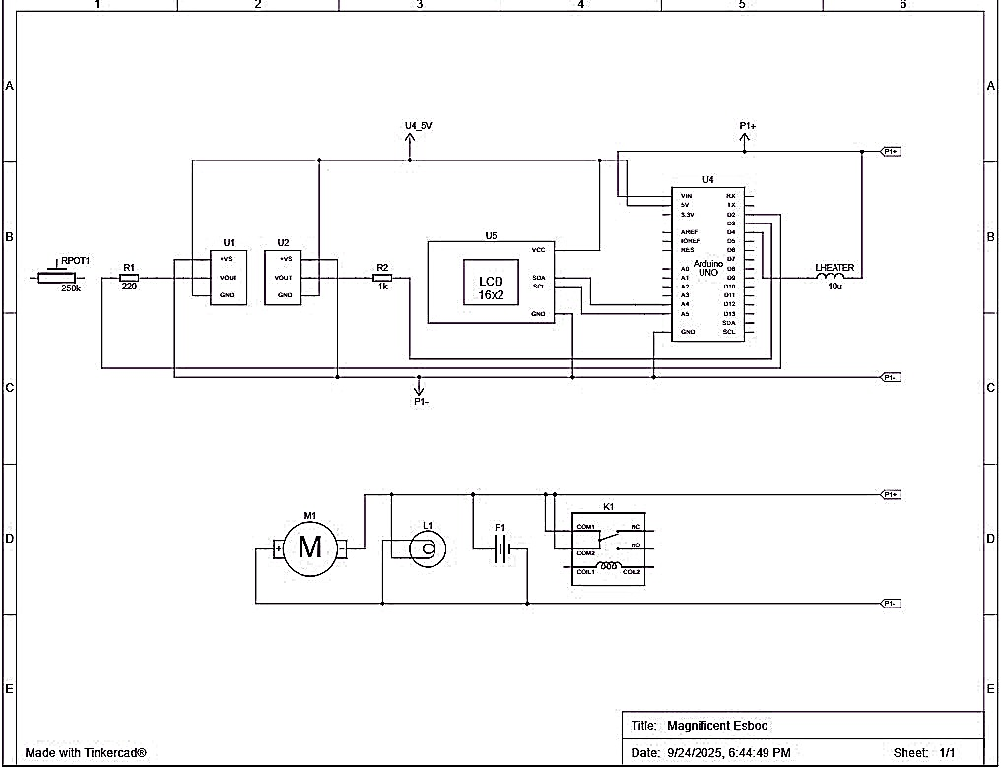
Figure 3.1: Circuit Diagram of the System
3.3 Flow chart diagram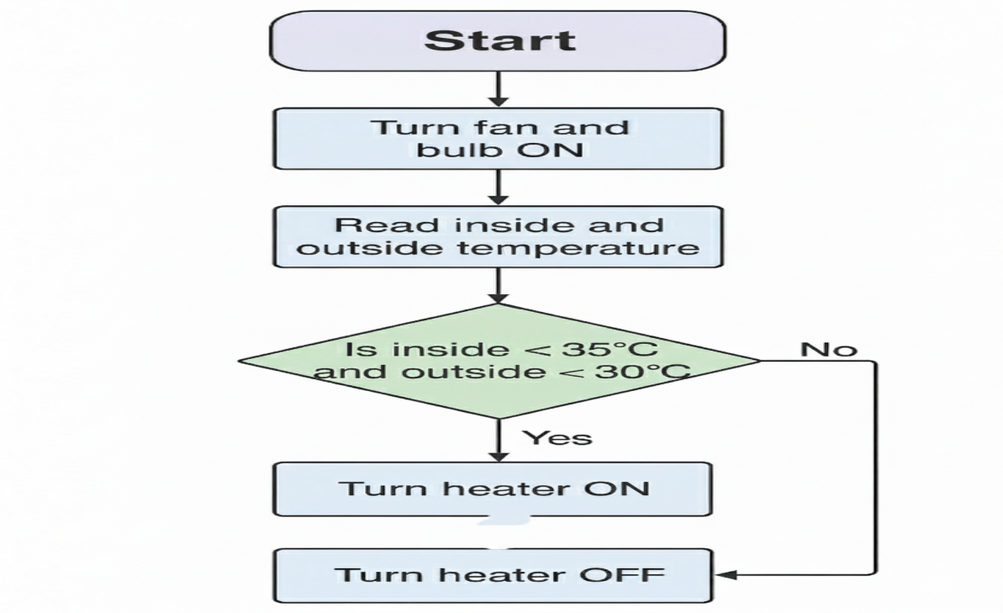
Figure 3.2: Flow Chart Diagram of how the Command Flows in the System

3.4 Block diagram

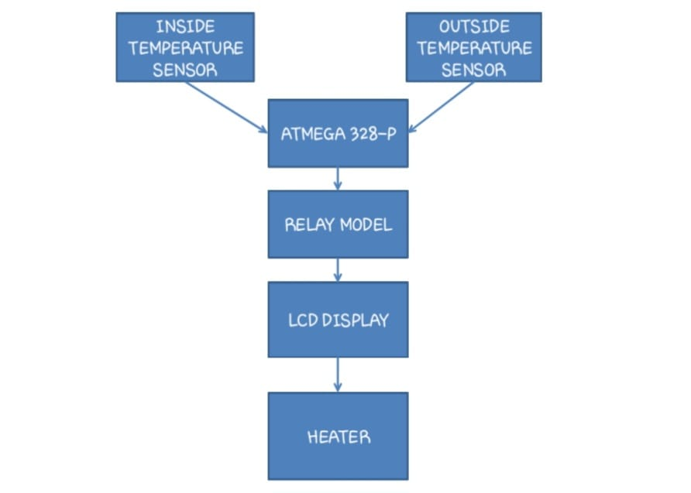
Figure 3.3: System Block Diagram
3.5 Images of the Prototype
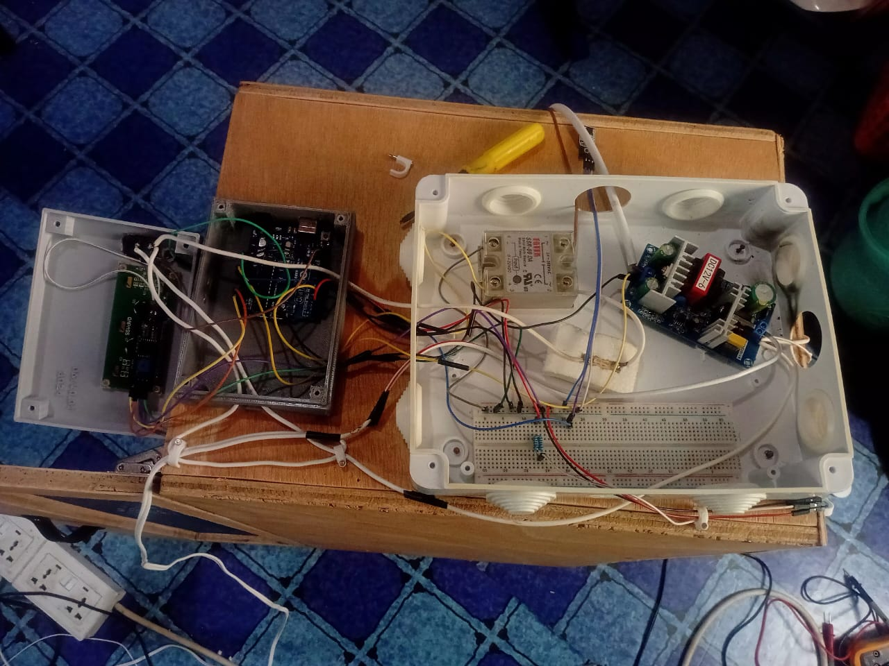
Figure 3.4: Connections of the Prototype

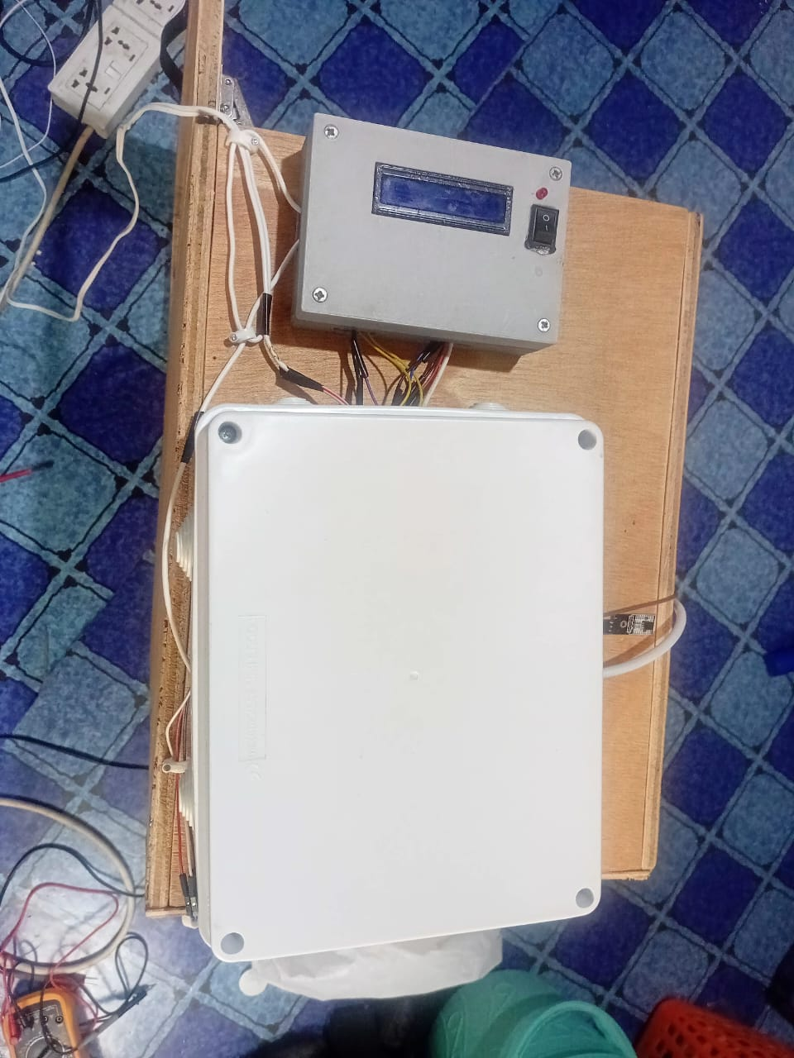
Figure 3, 5: Close-up of the connection in a plastic container

3.2 Materials and Components
TAB 3.1
Component | Specification / Quantity
Arduino Uno | 1
DS18B20Sensor | 1
Relay Module | 2-channel, 5V
Heater | 60W(1)
LCD Display | 16x2
Power Supply Unit | 5V/12V Regulated
Breadboard & Jumpers | As required
Resistors & Capacitors | As required
Brooder Box | 1
LM35 sensor | 1
Fan | 5V DC (1)

3.3 Method of Data Collection and System Testing
The data collection and testing involve the following steps:
- Prototype Testing: The assembled system was tested in a controlled environment to verify if it maintains desired temperature levels.
- Sensor Calibration: The accuracy of the sensor was checked by comparing readings from multiple temperature sensors.
- Time taken to heat the brooder space
- Stability of temperature over time
- Response time of switching between the heater and the fan

3.4 Instrumentation (Construction, Validity, and Reliability)
In all technical and scientific activities, instruments are used for observation, data collection, and system performance evaluation. A combination of hardware components, software tools, and manual verification procedures was used to construct the system and validate its functionality for this experimental and developmental study on an Automatic Temperature Controlled Brooder House. This section discusses the instruments used, their design, and the steps taken to ensure their validity and reliability.

3.5 Instrument Construction
The primary instrument in this project was the automated brooder system itself, which was constructed using the following key components:

3.5.1 Temperature Sensors (DS20B18 and LM35)
These components determine the brooder environment's temperature in real time.
3.5.2 Arduino Uno Microcontroller
Defines thresholds and uses them to interpret sensor data and regulate outputs (heater).
3.5.3 Relay Module (5V)
Serves as an electrical switch to activate or deactivate the fan or heater.
3.5.4 Heater
Produces heat when the relay triggers it. 3.5.5 Cooling Fan (12V DC): Cools the environment or circulates air when the temperature rises above predetermined thresholds.
3.5.6 LCD Display:
Shows current temperature data and system status.
In order to ensure a compact arrangement within a protective enclosure that resembled a brooder box, the components were physically constructed by wiring them on a breadboard.

3.6 System requirement analysis
The first step was to clearly define the objectives and requirements of the system. The following components were sourced: Arduino Uno microcontroller(ATMEGA 328-P). This means figuring out the best temperature range for brooding poultry, which is between 35°C and 40°C. To monitor the temperature in real time, we picked suitable temperature sensors (DS20B18 and LM35). I created a feedback loop that compares the temperature constraints with the sensor data. Managing with Logic builds a control system that controls sensor data and activates control devices, like a heater, using an ATMEGA 328-P. The ATMEGA 328-P was configured to gather sensor data and activate the heater in response to temperature readings using the Arduino IDE.
User Interface: I used an LCD to show the current temperature and system condition.

3.7 Design and Construction of Circuits
Circuit Schematic: The electrical schematic of the system was made using a program such as Proteus in order to show the connections between the various parts (sensor to Arduino, relay to devices).

3.8 Configuring the ATMEGA 328-P Control System Code Development
The Arduino IDE was used to program the ATMEGA 328-P. The temperature sensor's data is periodically read by the program. The heater is turned on if the temperature falls below the threshold (30°C). The heater is switched off if the temperature rises above the cutoff point of 40°C. The system status and current temperature are shown on the LCD.
3.8.1 Testing of Code
The code was tested using the built-in serial monitor of the Arduino IDE, where print statements were used to verify and debug control commands and sensor readings.

3.9 System Testing
Initial Testing: The system was powered on, and the temperature readings from the sensor were monitored in real-time. The control logic was verified by checking whether the heater was switched on or off correctly based on the temperature.
Environmental Testing: The system was tested in a simulated brooder environment (a small enclosure mimicking a poultry house) with varying ambient temperatures. The temperature was raised above the threshold (40°C) to test if the heater would be deactivated. Similarly, the temperature was reduced below the threshold (30°C) to check if the heater turned on.
Data Collection: Temperature readings were logged at 30-minute intervals to assess how well the system maintained the desired temperature range over 12 hours.

3.10 Evaluation and Calibration The system's performance was evaluated based on the following criteria:
Temperature Control Precision: Whether the system maintained the temperature between 30°C and 40°C without excessive oscillation.
Response Time: The time it takes for the system to activate the heater after detecting a temperature change.
System Stability: The ability of the system to run continuously for long periods without failure or overheating.

3.11 Documentation and Reporting
The schematic shows how to connect the parts on a breadboard. Once the wiring is checked, the system will be transported to a board with holes in it for permanent assembly. Distributing power to make sure that all parts (Arduino, sensor, relay, fan, heater) got the right voltages, proper voltage regulation was put in place. Programming the ATMEGA 328-P Control System: Writing Code. I used C/C++ in the Arduino IDE to program the ATMEGA 328-P. The application gets data from the temperature sensor regularly. The heater turns on when the temperature drops below 30°C. The heat turns off when the temperature goes beyond the threshold (38°C). The LCD screen indicates the current temperature and the status of the system. Testing of Code, I used the serial monitor that came with the Arduino IDE to test the code. Print statements were used to validate and troubleshoot sensor data and control commands. Testing and System Integration, after the code was written and the hardware was put together, the integrated system was tested. First tests. The temperature data that the sensor recorded in real time was analyzed after the device was turned on. I was able to verify the control logic by examining whether the heater and fan responded to temperature changes as intended.

3.12 Data Collection
The primary data collected includes temperature readings from the temperature sensors at regular intervals (every 30 minutes) over a continuous testing period. Time to visually represent the system's ability to maintain the set point over a prolonged period. Once the wiring was checked, the system was transported to a board with holes in it for permanent assembly. Programming the ATMEGA 328-P control system, writing code I used the Arduino IDE to program the ATMEGA 328-P. The application gets data from the temperature sensor regularly. The heater turns on when the temperature drops below 30°C and turns off when the temperature goes beyond the threshold (40°C). The LCD screen indicates the current temperature and the status of the system. Testing code, I utilized the Arduino IDE's built-in serial monitor to test the code. Print statements were used to check and debug sensor data and control commands.
Again, testing and integrating the system after putting the hardware together and writing the code, the combined system was put through tests. Testing at the start. The system was turned on, and the sensor's temperature data were checked in real time.
I checked the control logic by seeing if the heater and fan turned on and off correctly depending on the temperature.
Additionally, the device was tested in a simulated brooder setting, which is a small cage that looks like a poultry coop, with different temperatures to see if the heat would still be on if the temperature was raised above the threshold (40°C). In the same way, the temperature was lowered below the threshold (30°C) to see if the heater turned on.
Gathering Data: To see how successfully the system kept the temperature range during 6 hours, temperature readings were taken every 30 minutes.

3.13 Conclusion
The combination of quantitative data analysis (focusing on temperature control, stability, and response time) and qualitative observations (focusing on system behavior and real-world performance) provides a comprehensive method for evaluating the Automatic Temperature Controlled Brooder House. The statistical and graphical representations allow for objective analysis, while qualitative insights offer valuable context for system refinement and improvement.

CHAPTER FOUR
RESULTS AND DISCUSSION

4.0 Introduction
This chapter presents the results obtained from the development, construction, and testing of the Automatic Temperature Controlled Brooder House. It talks about how the system components were integrated to achieve the desired functionality. The results are analyzed to show how the system responds to varying temperature conditions inside and outside the brooder house and how it maintains the optimal temperature range required for chick growth. The system was tested by leaving it on overnight, about 8 to 12 hours, and the system was still working in good condition after that time. This tells how reliable the system is. The only challenge is whether there should be a power shortage since it doesn’t have a backup power source.

4.1 Selecting Components
I carefully selected the following components based on availability, accuracy, compatibility with Arduino Uno, and suitability for the environmental conditions in a brooder house.

4.1.1 Component Specification and Reason for Selection
Arduino Uno
ATmega328P is Reliable, very easy to program, and interfaces with multiple sensors.

DS18B20 and LM35 Temperature Sensors
Digital, 9 – 12 bit resolution, has an accurate temperature reading with a waterproof design.
Relay Module (1-Channel)
It is a 5V logic, 10A load switching, which is used to control the heating and cooling components of the system.
LCD Display (16x2, I2C)
Made up of an I2C interface, compact and low pin count, ideal for small displays
Heater 100W Incandescent Bulb
This is the heating element that provides sufficient warmth for chicks
Fan
A 5V DC Fan is effective for circulating temperature in the brooder house.
Resistors
A 4.7kΩ resistor is used for the DS18B20 data lines
Power Supply 12V Adapter
This supply powers the Arduino, relay, heater, and fan
Breadboard & Jumpers: I used them for prototyping and interconnections

4.2 System Implementation

4.2.1 Wiring
All components were carefully connected based on the circuit schematic diagram. I2C LCD was connected to A4 (SDA) and A5 (SCL). DS18B20 and LM35 temperature sensors were connected to D2 and D3, each with a pull-up resistor. The relay input was connected to D4.
4.2.2 Programming
Arduino IDE was used to upload the code. The logic checks temperature readings and activates the heater accordingly.

4.2.3 Casing
The entire circuit was enclosed in a plastic container for protection, and the sensors were mounted for easy ambient and external temperature sensing.

4.3 Results and Testing
TAB 4.1
Test Condition | Inside Temp | Outside Temp | System Action | Expected Outcome | Pass/Fail
Normal ambient conditions | 36°C | 32°C | None | Stable Temp | Pass
Cold external + low inside temp | 32°C | 25°C | Heater ON | Heater activates | Pass
Hot external + high inside temp | 40°C | 35°C | Heater OFF | Heater de-activates | Pass
Room temperature within limits | 38.5°C | 30°C | None | Stable Temp | Pass
Extreme low temp (night) | 30°C | 20°C | Heater ON | Heater activates | Pass

4.4 Comparing two heating elements (incandescent bulb and heater)

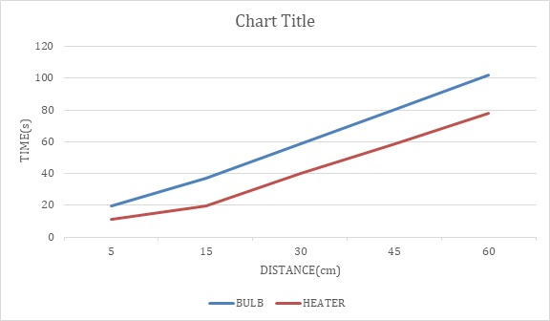
Figure 4, 1

With this test, I conducted to find the time taken for the heat to circulate evenly in the brooder house, and I realized that with the help of the fan, circulation is faster. Comparing the incandescent bulb to the heater, I can conclude that the heater is approximately 24 seconds faster than the incandescent bulb (23.94 seconds).
To reduce the time taken for the heat to circulate in the brooder house, two or more heaters are recommended in the brooder house if it is very big compared to my prototype.

4.5 Cost Estimation
TAB 4.2
Components | Quantity | Unit Cost | Total (GHS)
Arduino Uno | 1 | 145 | 145
Temperature Sensors | 2 | 30 | 60
Relay Module (1-Channel) | 1 | 40 | 40
16x2 I2C LCD Display | 1 | 60 | 60
DC Fan (12V) | 1 | 100 | 100
Heating Bulb (60W) | 1 |  | 150
Resistors + Jumper Wires | As required | 30 | 30
Power Adapter (12V & 5V) | 1 | 50 | 50
Breadboard | 1 | 20 | 20
Total Estimated Cost |  |  | 655

4.6 Challenges Encountered

4.6.1 Sensor Calibration
Initial readings required verification using a digital thermometer. Initially, I intended to use two DS18B20 sensors, but one of them was faulty, and I had to change it for a LM35 temperature sensor.

4.6.2 LCD Flicker
There was a problem with the temperature readings appearing on the LCD display, and I fixed it by checking the connected cables and looping some pins of the LCD to modify my programming code to suit my desired display.

4.6.3 Relay Switching Noise
There was a sudden noise from the relay model. I added a diode to improve protection.

4.6.4 Code Debugging
Multiple codes had to be generated to fit my desired operation of the prototype. So many iterations were required to ensure error-free logic.

CHAPTER 5

CONCLUSION AND RECOMMENDATIONS

5.0 Introduction
This project was successfully implemented an Automatic Brooder House using an Arduino Uno microcontroller, two temperature sensors, a 16x2 I2C LCD display, a relay module, a DC fan, a heating element, and a bulb. This project would improve operations, decrease the amount of manual labor required, and raise the chicks' survival rate.
Two temperature sensors form the basis of the system's logic: one outside the brooder house to measure the air temperature and one inside the brooder to directly monitor the temperature conditions that impact the chicks. This two-input logic allows the ATMEGA 328-P to make better decisions about whether to heat or cool the brooder home to improve the chicks' comfort. If the temperature inside falls below 35°C, the device will automatically turn on the heating lamp to warm the chicks.
Adding several temperature sensors and relays throughout the house would make zoning possible. This zoning plan makes sure that each part of the brooder house gets its own thermal management based on the temperature readings in that area.

5.1 Recommendations

5.1.1 Safety Enhancements
Safety mechanisms like overheat cut-off switches, flame sensors, and thermal fuses should be incorporated to prevent accidents or fires in case of system failure. Additionally, an audible alarm or visual LED indicator could be added to alert users in case of overheating. The heater remains off when the brooder house's internal temperature remains between 38°C and 40°C. This prolongs the life of the components used to construct the brooder home and saves energy. For chicken farmers who have multiple brooding units or who reside in remote or small areas, this kind of automation will be very helpful. By eliminating the need for frequent manual supervision, it saves time and effort and improves the consistency of raising chicks. To sum up, the project demonstrated how to integrate open source hardware with embedded systems, which was both helpful and educational.

5.1.2 AI-Based Control Algorithms
Future improvements could include machine learning algorithms that adaptively adjust temperature thresholds based on chick age, weather forecasts, or past environmental behavior, making the system more intelligent and responsive.

5.1.3 Summary
In conclusion, the Smart Automatic Brooder House project effectively demonstrated the feasibility and practicality of using microcontroller-based systems for agricultural automation. With appropriate enhancements and safety features, this system has the potential to serve as a low-cost, scalable solution for poultry farmers seeking to modernize their operations.

APPENDIX

Cost Estimated

The cost estimated above was actually the initial cost and what I intended to spend on the project, depending on the components listed and used. After the creation of the prototype, I ended up spending more than the estimated amount due to some unexpected instances like replacing faulty components, creating a wooden structure as a brooder house, adding new components to better the project, and transportation in getting all the components needed.

REFERRENCES

- Ahmed, M., Islam, S., & Hossain, M. A. (2020). IoT-Based Smart Brooder System for Rural Farmers. International Journal of Computer Science and Network Security, 20(4), 145-151.
- FAO. (2022). The State of Food and Agriculture 2022: Harnessing Agricultural Automation for Sustainable Development. Food and Agriculture Organization of the United Nations.
- Nwachukwu, O. A., et al. (2015). Comparative Analysis of Traditional and Automated Poultry Brooding Systems. Journal of Agricultural Engineering and Technology, 23(1), 1-10.
- Bambale, N., & Abubakar, S. (2018). Economic Impact of Adopting Automated Poultry Management Systems in Sub-Saharan Africa. Journal of Agricultural Economics and Rural Development, 4(1), 12-21.
- Kumar, R., et al. (2021). Comparative Study of Automation and Conventional Systems on Production Performance in Poultry Farms. Journal of Animal Research, 11(1), 188-195.
- Gao, H., et al. (2019). Review of Internet of Things Technology Applications in Precision Livestock Farming. Computers and Electronics in Agriculture, 162, 1051–1060.
- Sharma, R., & Jain, S. (2020). Challenges and Opportunities for IoT Implementation in Small-Scale Farming. IEEE Transactions on Industrial Informatics, 16(5), 3450-3459.
- Srivastava, J. P. (2017). Automation in Agriculture: Trends and Future Directions. International Journal of Modern Engineering Research, 7(6), 1-8.
- Oluyemi, J. A., & Roberts, F. A. (2000). Poultry Production in Nigeria. Macmillan Education.
- Adeyemo, O. S., et al. (2017). Automated Brooder System using LM35 Sensor for Temperature Control. Journal of Engineering and Applied Sciences, 12(15), 3848-3852.
- Nse, S. U., et al. (2018). Optimal Environmental Conditions for Day-Old Chicks during Brooding Period. Poultry Science Journal, 97(5), 1545-1552.
- Shahzad, M. K., & Javed, M. (2019). Analysis of Thermal Stress Mitigation Techniques in Intensive Poultry Farming. Agricultural Engineering International: CIGR Journal, 21(3), 114-123.
- Adegboye, S., & Ogunrinde, A. (2020). Design and Construction of an Automatic Climate Controller for Poultry House. Nigerian Journal of Technology, 39(1), 154-160.
- Bisen, M., & Verma, S. (2016). Effects of Temperature and Relative Humidity on Broiler Performance and Health. Veterinary Medicine International, 2016, 1-8.
- Kumar, P., & Singh, R. (2022). Brooding Temperature Requirements and Management Strategies for Different Poultry Species. Indian Journal of Animal Sciences, 92(4), 430-435.
- Iroegbu, C. (2016). Low-Cost Automated Poultry Incubator Using Arduino. International Journal of Engineering and Applied Sciences, 3(8), 56-62.
- Patil, P., & Khairnar, S. (2018). Arduino-Based Smart Chicken Farming Using Temperature Sensor and Automated Feeding Device. International Journal of Research in Engineering and Technology, 7(2), 22-26.
- Adeyemi, O. E., & Ajayi, O. (2021). Design and Implementation of an Integrated Temperature Control System for Chicken Brooder using Arduino Uno. Journal of Universal Studies and Development, 3(2), 1-10.
- Atmel Corporation. (2015). ATmega328P Microcontroller Technical Data Sheet. San Jose, CA: Atmel.
- Lee, J., & Kim, H. (2017). Design of a Low-Cost Wireless Sensor Network Node for Agricultural Monitoring. Sensors, 17(5), 1050.
- Manlangit, E. J. D. (2022). Development of an Automatic Temperature Control Brooder System For Chicks. Research Project, Technological University of the Philippines, Visayas.
- Al-Fuqaha, A., et al. (2015). Internet of Things: A Survey on Enabling Technologies, Protocols, and Applications. IEEE Communications Surveys & Tutorials, 17(4), 2347-2376.
- Ganesan, K., & Kumar, S. (2019). Interfacing High Power AC Loads with Microcontrollers Using Solid State Relays: Practical Considerations. Journal of Electronics and Communications Engineering, 14(2), 55-61.
- Abdullah, A. A., et al. (2019). GSM-Based Water Level and Temperature Monitoring System. International Journal of Advanced Research in Engineering and Technology, 10(2), 200-208.
- Singh, A., et al. (2020). Modular Embedded System Design for Scalable Precision Agriculture. IEEE Access, 8, 145000-145012.
- DS18B20 Digital Thermometer. (2017). Maxim Integrated Products Technical Data Sheet.
- LM35 Precision Centigrade Temperature Sensor. (2018). Texas Instruments Technical Data Sheet.
- Smith, J. R., & Taylor, B. N. (2008). Guidelines for Evaluating and Expressing the Uncertainty of NIST Measurement Results. National Institute of Standards and Technology.
- Jomar, P. (2020). Measuring Temperatures with LM35 and DS18B20: A Dual Sensor Approach. Arduino Project Hub.
- Rossi, F. (2019). Calibration of DS18B20 Sensor With Arduino UNO: The Two-Point Method. Instructables.
- Zhang, Y., & Wang, J. (2015). Comparative Study on Accuracy and Stability of Digital and Analog Temperature Sensors for Environmental Monitoring. Sensors and Actuators A: Physical, 223, 150-157.
- Bhoyar, S., et al. (2021). Drift Compensation and Noise Reduction Techniques for Temperature Sensors in IoT Applications. International Journal of Sensor Networks, 35(1), 25-38.
- NIST. (2019). Temperature Calibration Methods and Best Practices. National Institute of Standards and Technology.
- Wadhwa, M. K., & Kaur, S. (2018). Sensor Data Fusion Strategies for Enhanced Reliability in Agricultural Monitoring Systems. Journal of Intelligent Systems, 27(4), 450-465.
- Oladele, S., & Femi, E. (2020). Embedded System Metrology: Ensuring Accuracy in Low-Cost Agricultural Sensors. African Journal of Engineering Research, 8(3), 112-120.
- Liptak, B. G. (2017). Instrument Engineers' Handbook, Volume 2: Process Control and Optimization. CRC Press.
- Li, W., & Yang, X. (2023). Implementation of Control Theory in Smart Farming Systems: A Review. Australian Science Journals, 3(1), 1-8.
- Angeli, D., & Sontag, E. D. (2014). Monotone Control Systems in Biology and Engineering. Journal of Differential Equations, 257(10), 3822-3855.
- Ogata, K. (2010). Modern Control Engineering (5th ed.). Prentice Hall.
- Johnson, R., & Smith, L. (2019). PID Controller Tuning Techniques for Thermal Systems in Agricultural Applications. ISA Transactions, 91, 10-19.
- Al-Kharouf, M., & Hammouri, Z. (2018). Modeling and Simulation of Thermal Dynamics in a Poultry Brooder Environment. Journal of Thermal Biology, 78, 115-125.
- Sastry, S. (2013). Nonlinear Systems: Analysis, Stability, and Control. Springer Science & Business Media.
- Adeyemi, O. E., & Ajayi, O. (2021). Temperature Control Program Development Using Arduino for Poultry Brooding. Journal of Universal Studies and Development, 3(2), 1-10.
- Wang, H., & Chen, J. (2020). Adaptive Control Algorithms for Energy-Efficient Climate Management in Greenhouses. Computers and Electronics in Agriculture, 175, 105574.
- Sharma, P. K., & Gupta, A. (2016). Performance Evaluation of PID versus Fuzzy Logic Controllers for Thermal Regulation in Brooding. International Journal of Advanced Research in Electrical, Electronics and Instrumentation Engineering, 5(8), 6932-6939.
- Irubor, S. C., & Igimoh, J. (2017). Design and Implementation of a GSM-Based Tank Water Level Control System. International Journal of Electrical and Computer Engineering, 7(4), 1837-1845.
- Sultana, M., et al. (2019). Study and Designing of Microcontroller-Based Temperature Sensing System Along with Global System for Mobile (GSM) Interface and Alarm Mechanism. International Journal of Mechanical Engineering and Technology, 10(7), 400-410.
- Paruchuri, S., et al. (2023). Remote Temperature Monitoring and Alerting System using IoT. 14th International Conference on Computing, 112-117.
- Smith, A., & Jones, B. (2021). User Interface Design Principles for Agricultural IoT Dashboards. Journal of Agricultural Informatics, 12(1), 1-15.
- Chen, L., & Hu, M. (2018). Network Topology Selection and Reliability Assessment for Wireless Sensor Networks in Large-Scale Poultry Houses. IEEE Sensors Journal, 18(19), 8110-8118.

